Initial Evaluation
- Thorough history and physical exam
- Prior surgeries and prior SBO
- Inspect for hernias and perform a rectal exam
- CBC, Chem 7, lipase, lactate
- CT abdomen
- IV contrast (no PO contrast)
Immediate Surgery If:
- Concern for bowel ischemia
- Abdominal sepsis
- peritonitis
Inclusion
- Prior history of abdominal surgery
- SBO obstruction on CT
Exclusion
- Disseminated cancer
- Intra-abdominal infection
- Bowel ischemia
- Incarcerated hernia
- Pregnancy
Conservative Management
- NG tube decompression
- Foley Catheter
- IV fluids
- Head of bed>30 degrees
- Abdominal exam at least every 4 hours
- Daily CBC and Chem 7
Omnipaque Protocol
- At least 2 hours of NG decompression first
- Within 8 hours of admission physician administers 100mL UNDILUTED oral water soluble contrast Omnipaque (2 bottles)
- Clamp NG for 1 hour
- KUB at 8 hours and IF needed at 24 hours
We will now be stocking a small amount of Oral Contrast ( OmniPaque) for SBO’s coming into the Emergency Department. (relevant to PGY3 ED seniors and moonlighters)
HOW TO ENTER ORDERS
Ordering Omnipaque
- Order Sets
- “FL contrast”
- Imaging “other”
- Iohexol Omnipaque 240
- 100mL/OraL
- Type “to be administered by physician for small bowel obstruction pathway” in the comments section
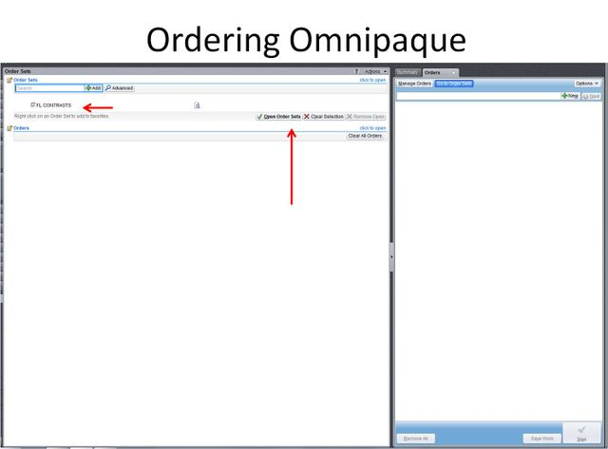
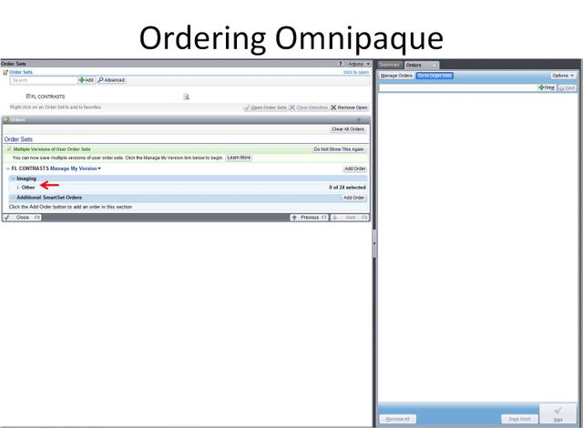
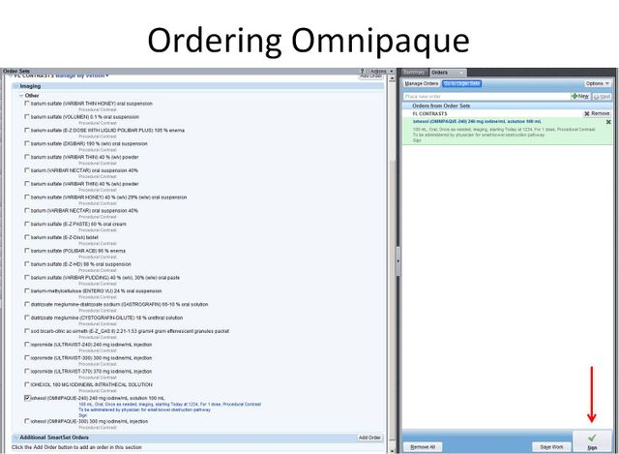
Ordering KUB
- Orders
- KUB
- AP only
- Today/Time (8 hours after contrast and again at 24 if needed)
- “for small bowel obstruction pathway”
