E-PRIV
What is E-PRIV?
Real-time, read-only access available to all MGB employees to view provider and privileging data including demographic, appointment, license, malpractice coverage information, and privileges.
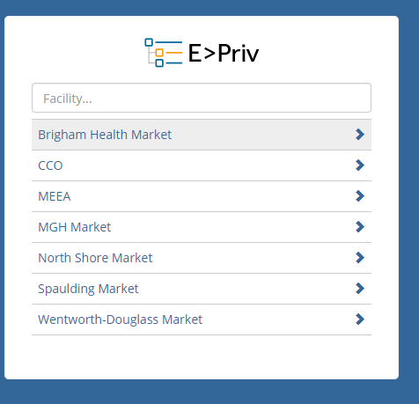

How do I access E>Priv at Mass General Brigham to see provider privileges and key demographic information?
To access E>Priv:
    - https://login.mdstaff.com/partners/epriv
    - Mass General Brigham Start Menu > MD-Staff EPriv
    - Preferred browsers: Chrome, Safari (Note: images will not display consistently using Internet Explorer)

- To view the profile/privileges data, please choose the CCO view.
  - The categories you will see include demographic, appointment, education, credentials, board certification, insurance, scanned documents, and privileges.
- To view profile/privileges data in E>Priv, please select the location you are affiliated with. For example, the BWH Health Market (BWPO) or MGH Market (MGPO) views.
    - Under this section you will see demographic, appointment, address, provider health plan information including ID number and effective dates, board certification and credentials.

