HOW TO REGISTER FOR 5th ANNUAL COLORECTAL CANCER IN AFRICA: RAISING AWARENESS
- Navigate to the course landing page: https://cpd.partners.org/content/5th-annual-colorectal-cancer-africa-raising-awareness

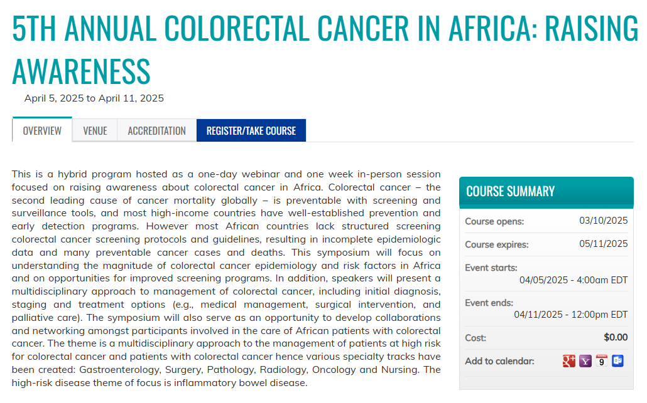
- Click on the ‘Register/Take Course’ tab

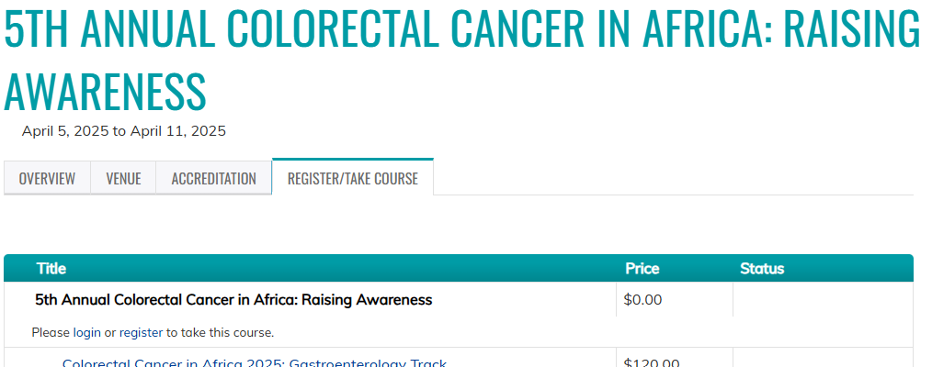
- Click ‘Register’ to create a new account.
* If you have an account on our site, click ‘Login’ & login using your account credentials.

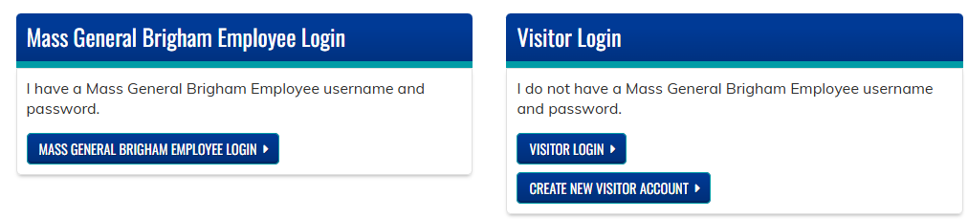
- Once redirected, click on ‘Create New Visitor Account’

- Complete the New Account form & then click ‘Create New Account’ at the bottom of the page.
- Once logged in, you will be redirected to the course registration page.
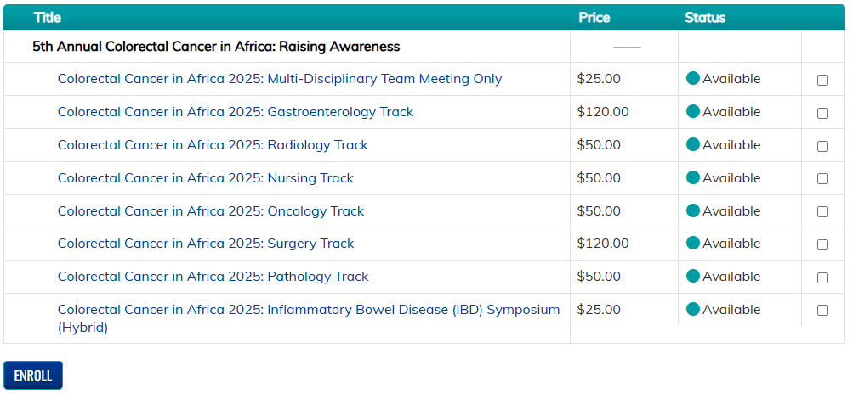
- Select the courses you intend to participate in. You may only enroll in one track.
** Note that all specialty tracks include the Multi-Disciplinary Meeting AND a 2-Day Hands-On Workshop. If you are registering for a specialty track, you do NOT need to register for the Multi-Disciplinary Meeting **


- Click the blue ‘Enroll’ button.

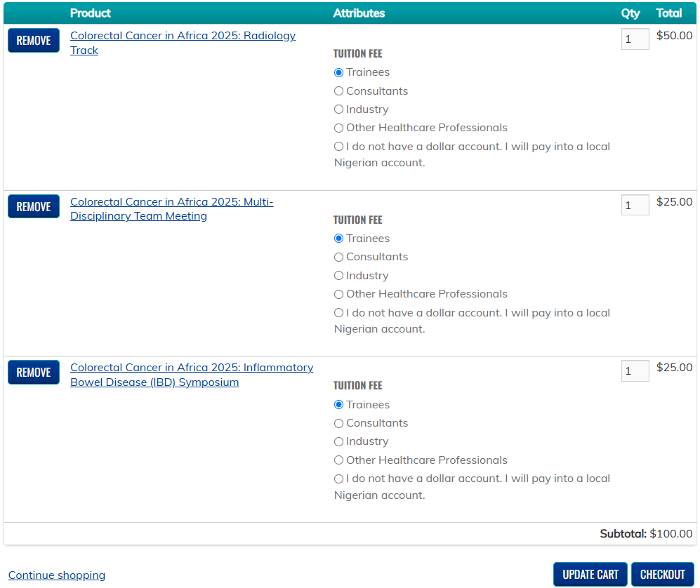
- Once redirected to your shopping cart, select the tuition fee type most applicable to you for each item.
** Note that tuition varies. **

- Click ‘Update Cart’ to confirm tuition fees.

- Click ‘Checkout’ once confirmed.

- Complete the required fields & then click ‘Review Order’ at the bottom of the page.

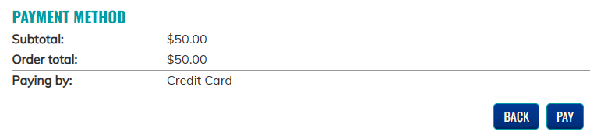
- Review your order & then click ‘Pay’
* NOTE: If you are paying into a local Nigerian account, you will be able to process your initial registration for free. However, your enrollment will not be confirmed until your tuition fee has been paid.

- Enter your credit card information & then click ‘Pay’

- You will receive a registration confirmation email, once your tuition fee has been paid & confirmed.

